Firmware Upgrade/Downgrade

# Case Upgrade R2-R3

## Pre-requisites

Configure standard network parameters.

Connect DTM to R2 device. Ensure it is working properly.

Make sure “factory defaults” are created. To test, execute RB.RESTART with “restore TB to factory”. If failed, even in OOS mode, execute RB.RESTART with value 42, Using NI Dialog, and verify “factory defaults” are created.

## Test

### Inspect and record flash bank for each CPU (FFP and APP) using SA:

* APP – command 129.41  
  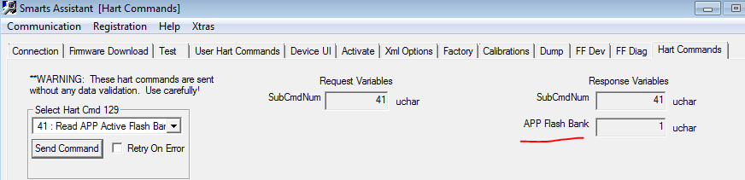
* FFP – command 255.9  
  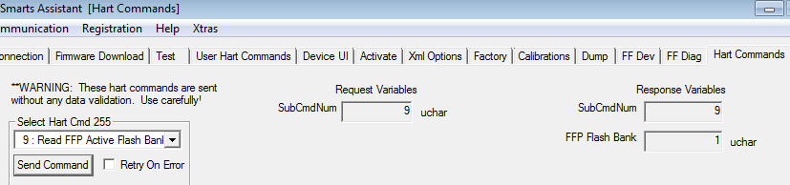

**Expected result**: each bank is either 0 or 1. Usually, the banks of FFP and APP match.

Select “Update Firmware” in DTM live list, select and download R3 image:

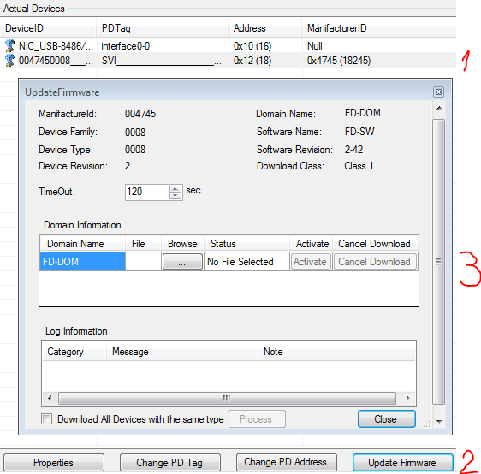

**Expected result**: successful completion in under 20-25 min on an empty bus

### Click “Activate”

**Expected result**: device resets and comes up with a temporary node address and visible in the live list. DTM dialog window shows failure. All FFP parameters will be lost, and all APP parameters, preserved.

Use any appropriate tool to set unique node address. E.g. click “Change PD address”

Write device access parameters as instructed:

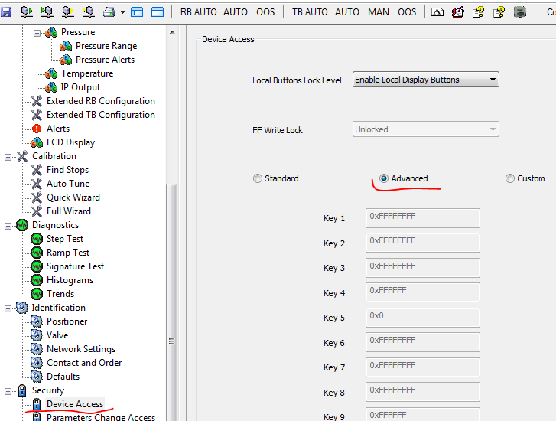

**Expected result**: device is fully operational

### Read flash banks (as before)

**Expected result**: Banks are the opposite to their original reads, for each CPU.

### Execute RB.RESTART with “restore TB to factory”.

**Expected result**: operation failed, even in OOS mode. This means, factory defaults are lost.

### Execute RB.RESTART with value 42, using NI Dialog

**Expected result**: “factory defaults” are created and RB.RESTART with “restore TB to factory” now works. To verify, change some parameters and see them restored.

### Inspect FBAP, tags, and block parameters

**Expected result**: empty FBAP, default tags and parameters

# Case Downgrade R3-R2

This is symmetrical to Case Upgrade R2-R3 but the initial device content is R3 and the resulting content is R2

# Case Up/Downgrade R3 to the same or different build of R3

This is similar to Case Upgrade R2-R3 but

1. Network parameters should be set to more aggressive settings appropriate for R3
2. Steps 4-6 are replaced as follows

### Inspect FBAP, tags, node address, and block parameters

**Expected result**: all parameters are preserved, unless there was a device reset/power cycle during activation process.

### Make sure to modify some TB parameters

### Execute RB.RESTART with “restore TB to factory”.

**Expected result**: operation succeeds, and TB parameters are reverted to the values before the firmware update.

# First run after firmware activation

Verify that the device on first run after activation comes up with correct device id and device and block tags, like so:

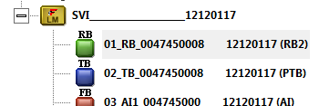

Verify that a phantom with device id ..._________________00000000 never appears in NI Configurator.

Test applies to update R2🡪R3 and R3🡪R3

## Steps

The first phase is with real upgrade/downgrade.

The second is with emulation of activation with HART command 255.10 “Flip Partition” to repeat several times:

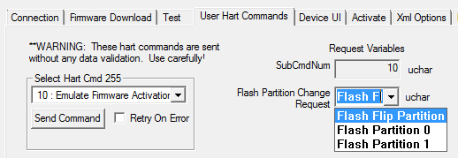

Doing so several times would ensure consistency of “first run” after activation without the expense of actual firmware update. The pre-requisite for this phase is both flash banks 0 and 1 contain valid firmware images (R2 and R3, R3 and R3)